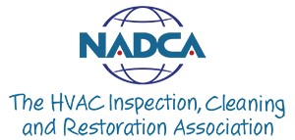
March 23, 2020
ESSENTIAL PERSONNEL MEMORANDUM

To Whom It May Concern:
THE NATIONAL AIR DUCT CLEANERS ASSOCIATION (NADCA) represents more than 1,300 small and large businesses and more than 3,000 certified technicians from across the United States and internationally, who perform a highly skilled and particularly essential service to healthcare facilities, commercial buildings, military facilities and homes.
Our members routinely provide service to maintain continuity of operations of the federal critical infrastructure sectors, as outlined at https://www.cisa.gov/identifying-critical-infrastructure-during-covid-19.
NADCA members perform source removal of contaminants from ductwork and clean and apply antimicrobial to HVAC systems and components where appropriate. Our members’ services are needed now more than ever as we work together with our facility partners to ensure a safe indoor environment for those businesses who are responsible for keeping our country and our citizens operational during these challenging times.
To verify NADCA membership, please visit the Find a Pro directory at nadca.com.

Please allow this Member to have access so that they may service their clients in the effort of ensuring maintenance of acceptable conditions at facilities providing health and medical care, veterinary and/or daily residential care facilities, and other services necessary to prevent an immediate threat to the health, safety, and welfare of the public.

Sincerely,
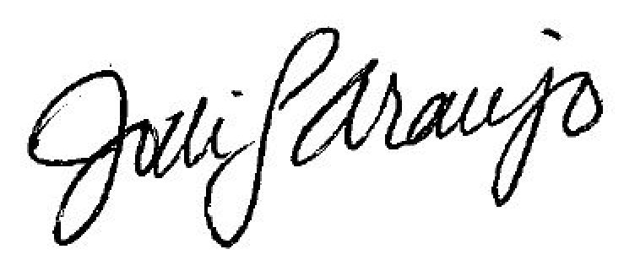
Jodi Araujo, CEM
Chief Executive Officer
NADCA

