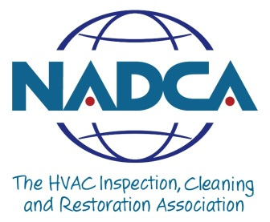
NADCA Code of Ethics (Regular Members)

1. We will serve our customers with integrity and competence.
2. We will perform our work using Source Removal methods. In order to eliminate or prevent the delivery of airborne pollutants into indoor air spaces, through HVAC ductwork, we will remove the dust and others contaminants from the system. Thus, we pledge to administer Source Removal methods, cleaning the system ductwork as thoroughly as possible, before applying any coatings or treatments, including deodorizers, disinfectants, and/or sealants.
3. We will be honest and forthright about our advertising.
4. We will provide our clients with accurate inspections and evaluations of the cleanliness and physical condition of their HVAC systems, using this information to determine the type of cleaning and maintenance services required, if any.
5. We will provide only necessary and desired services to our clients, and will not use furnace/air duct cleaning as a means of selling unnecessary or unwanted products or services.
6. We will provide services only after completing the necessary bonding and licensing procedures.
7. We will utilize the services and products of those who possess specialized skills, tools, or trades not possessed by us when circumstances call for work to be done which we are unable to perform.
8. We will stay abreast of new developments in technology, tools of the trade, building codes, the Uniform Mechanical Code, and any other codes or information that directly affects our work.
9. We will require that all employees of our firm practice furnace/air duct cleaning in accordance with NADCA Guidelines and the Code of Ethics.
10. We will perform our services in accordance with the current published standards of the association.
The NADCA™ Ethics Committee shall hear and investigate charges of unethical or illegal conduct between concerned parties, and will make recommendations to the Board of Directors concerning the resolution of those charges.

